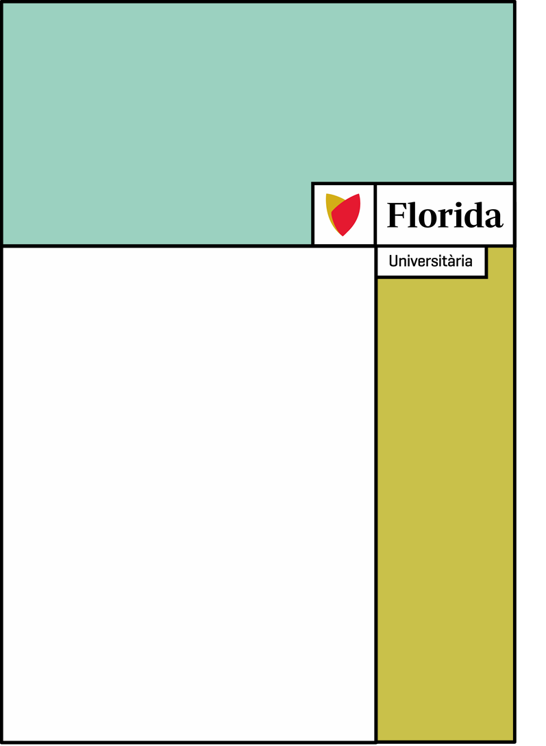

**2 daw – semipresencial**

**NAME: Georgi nedyalkov vankov**

**AEV1 -** **AN EMAIL OF APOLOGY**

**Dear Mr. John Wick,**

**I hope this email finds you well. We would like to begin by expressing our sincere apologies for not addressing your requests in a timely manner, as mentioned in your email dated September 13, 2023 (Ticket Number NZ#71731). We deeply regret this lapse in our service and understand the importance of a prompt response to your needs. We have already detected the error in the software responsible for displaying images and are taking immediate steps to correct it.**

**The person responsible for this area was absent during this period and unfortunately did not inform us of this situation. We do not look for excuses, as our corporate policy clearly states that we must address and resolve these types of situations effectively. Let me assure you that I take personal responsibility for correcting this situation.**

**Regarding your issue, Mr. John, we have assigned a dedicated team to work exclusively on your resolution and ensure a quick and effective solution.**

**While we typically follow a "first come, first served" approach, we deeply value our relationship with you. We recognize that our service standard was not met in this case and therefore we have implemented a priority queue for valued customers like you.**

**Considering your long-standing partnership with our company, we want to do more than just correct this mistake. We will work tirelessly to provide you with an immediate solution to the situation you are facing at no cost to you. Additionally, we offer you a 15% discount on your next project with us as a token of our appreciation.**

**We would be very grateful if you could confirm your agreement with this proposed solution.**

**We sincerely hope that this situation does not negatively affect our business relationship and that we can continue to work together successfully.**

**Once again, we sincerely apologize for any inconvenience this may have caused.**

**If you have any questions or concerns, please feel free to contact me personally at my phone number: 777-777-777.**

**Yours sincerely,**

**Director of Development**

**Georgi Vankov**